Model Presentation

Model Presentation Panel
Main panel where all models are presented. This panel is also referred to as the Sketch; see Useful Tips for Using the Graphical Interface — Sketch for additional usage tips.
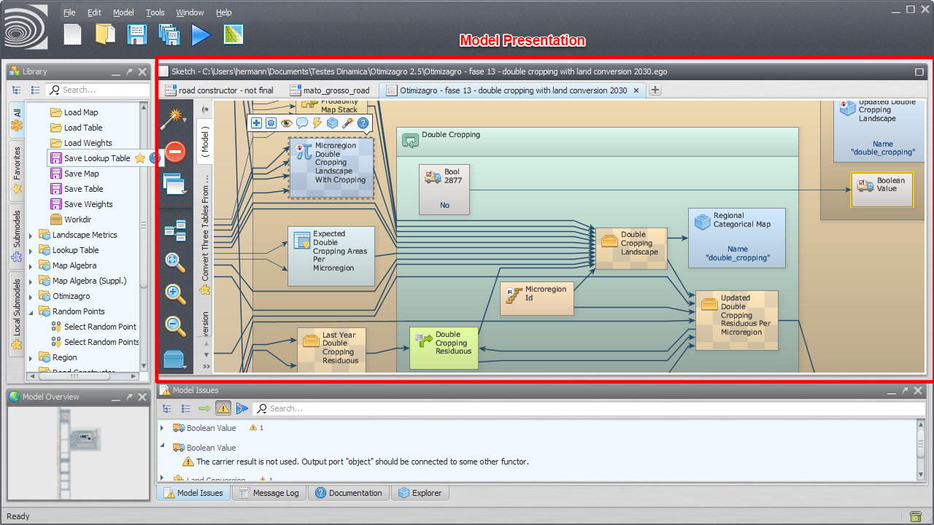Model Presentation
To open an existing model, drag the corresponding model script file from Windows File Explorer to the model presentation panel.
You can zoom using the mouse wheel, and pan by dragging the mouse while holding down the left button.

Functor Borders
The functor representation uses colored borders to convey status information. More than one border can be visible at the same time:
- Yellow border — the functor has one or more warnings.
- Red border — the functor has one or more errors.
- Green border — the functor exports input and/or output ports as part of a submodel.
- Blue border — the functor's input and/or output ports are exported to a wizard. Functors that are part of a submodel cannot export input and/or output ports to wizards.

Copying and Pasting as EGO Script
After copying the current selection using Copy Selection or Ctrl+C, the selection can be pasted either into another model or into an external text editor. When pasted into a text editor, the selection is written using its EGO Script representation; ports connected to functors that were not part of the copied selection are shown as disconnected (.UNBOUND). The settings under Tools → Options | EGO Script control how the fragment is written.
An EGO Script fragment copied from an external text editor can likewise be pasted directly into the model. The only requirement is that the fragment be syntactically valid; ports connected to variables whose definitions were not copied are treated as disconnected.

Model Selection Tabs
Tabs used to select the current model.
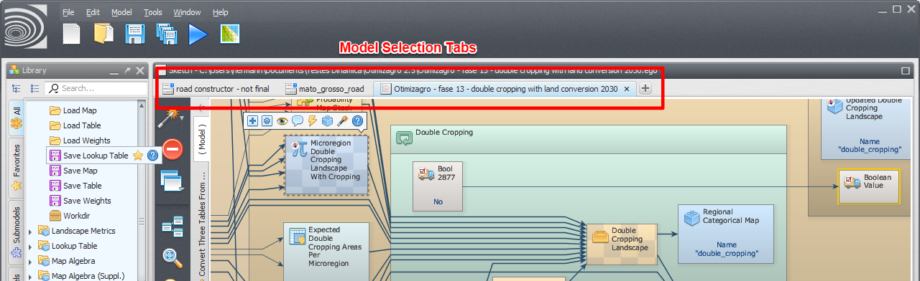Model Selection Tabs
Model tabs can be reordered by clicking and dragging them to a new location.
It is possible to scroll through a long list of open models by hovering the mouse over the model selection tabs and using the mouse wheel.
The path of the model open in a tab can be copied by hovering the mouse over the tab and pressing Ctrl+C, or by clicking the tab and choosing the corresponding option from the menu that opens; that menu offers a choice between the model's full file name and the name of the folder where it is saved.

Functor Action Bar
Allows the user to interact with the selected functor: editing, commenting, inspecting, etc. It is visible any time a functor is selected.
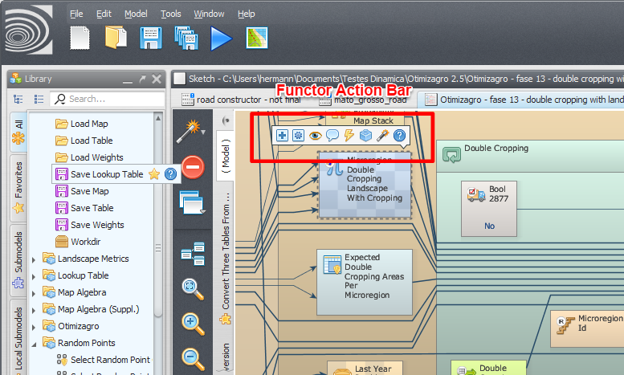Functor Action Bar
The operations available depend on the selected functor.
The functor action bar remains visible even when the selected functor itself is not visible on screen. In that case, the name of the selected functor is displayed on the bar, and clicking that name centers the view on the functor.
If multiple functors are selected, the action bar is not available.

Connecting Distant Functors
Two functors that are far apart, such that both are not visible on screen at the same time, can still be connected directly:
- Select the source functor and, without selecting the destination functor, scroll the view until the destination functor becomes visible — the source functor's action bar remains visible while doing so. Choose the create connection option on the action bar, then click the destination functor.
- Alternatively, click the source (output) functor — or search for it in the Explorer and click View functor there — then do the same for the destination (input) functor. Click the connection button on the action bar and, while the connection is still in progress, press Alt+Right Arrow to select the destination functor and bring it into view; click it to complete the connection.
Tip: Alt+Right Arrow and Alt+Left Arrow navigate between recent functor selections in general — Alt+Left Arrow returns to the previous selection and Alt+Right Arrow advances to the next one. Holding Alt while pressing the arrow keys skips across multiple selections.

Functor Information Panel
Opened by clicking the “?” icon on the Functor Action Bar, the functor information panel identifies which connection corresponds to a given port of the functor. Clicking a port name in its port list selects the corresponding connection in the model view.
The panel can also be used to find out which port is connected, being edited, or being viewed — this information is shown next to the corresponding port name.

Connection Action Bar
Allows the user to interact with the selected connection. It is shown in the upper-right corner of the panel whenever a connection is selected.
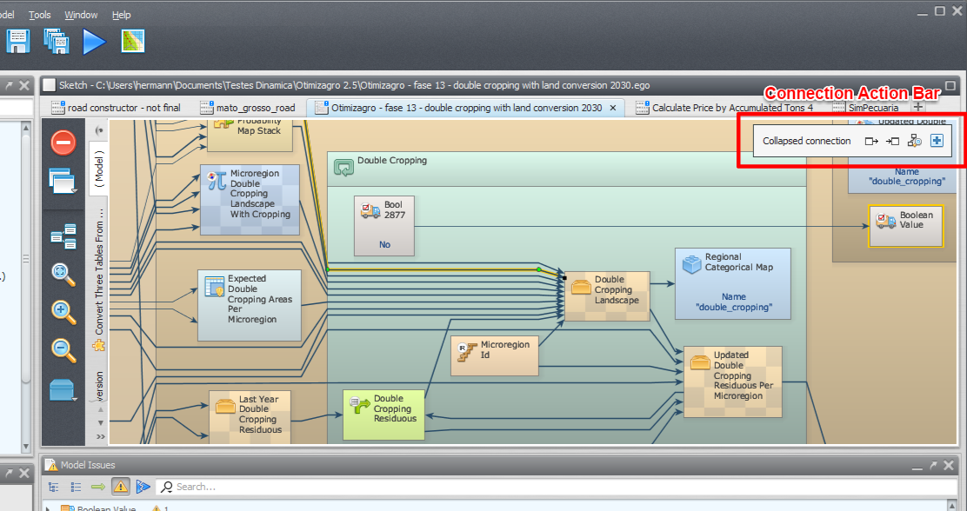Connection Action Bar
Hovering the mouse over the name of a port in the connection action bar displays a tooltip for that port and for the functor it belongs to, including its banner, comment, and alias.
The following video illustrates the use of the connection action bar to navigate connections.

Local Submodel Selection Tabs
Tabs used to select the current local submodel or the main model.
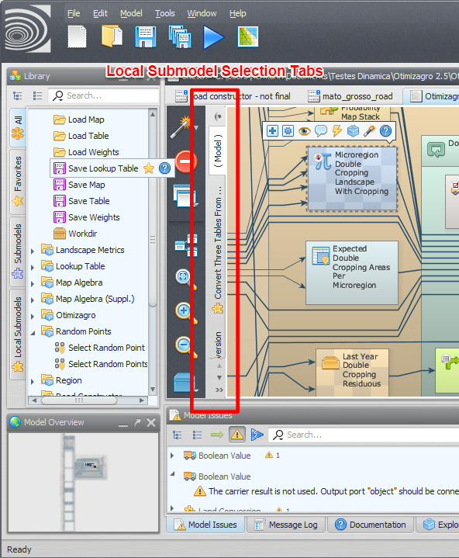Local Submodel Selection Tabs
The main model uses the name ( Model ). Local submodels have custom names and also use a custom icon.
Submodel tabs can be reordered by clicking and dragging them to a new location.
It is possible to scroll through a long list of submodels by hovering the mouse over the local submodel selection tabs and using the mouse wheel.
A submodel can be selected by clicking its corresponding tab among the model/submodel tabs, or by clicking the submodel overview button above them.
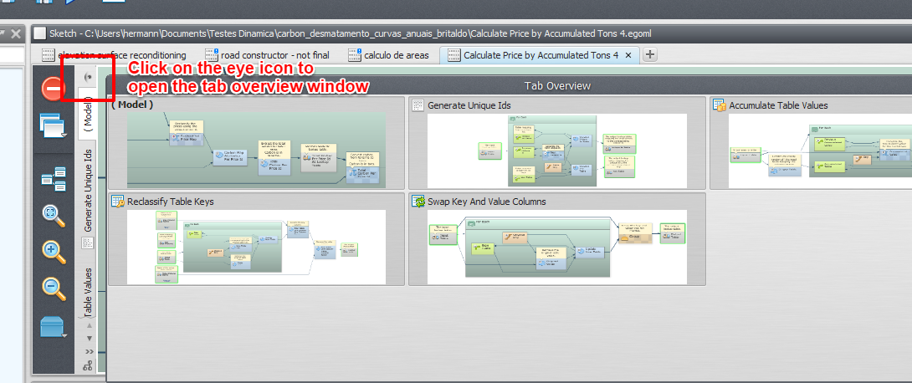Local Submodel Overview Button
Local submodel dependencies — including dependencies on user, store, and system submodels — can be viewed by clicking the dependency graph viewer button. See Submodel Dependencies for details.
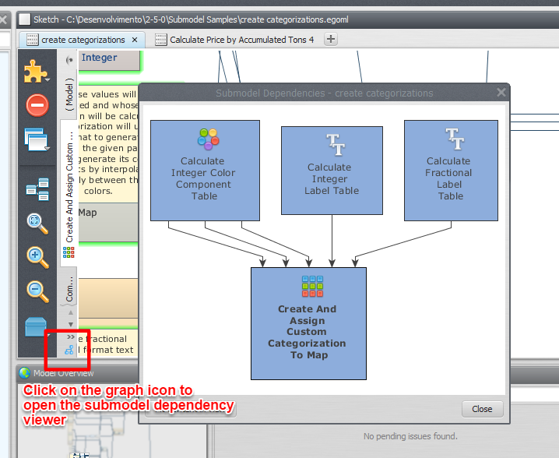Local Submodel Dependency Graph Viewer

See Also
- Submodels
- Functor Library
- Useful Tips for Using the Graphical Interface — Sketch

