Model Dynamics
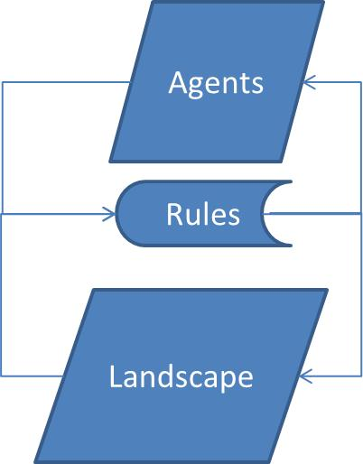
The model is composed by agents that interact with the environment which is a grid of cells with different amount of resources distributed. Agents and environment coexist through a set of behavior rules.
The agents have predefined genetic features (static attributes) as vision and metabolism, which determine the capacity to localize the resources and dawn them from the landscape, for example. Furthermore, the agents have dynamic and individual states as location and health. Landsacape also has attributes as resources recovery.
The model is fed back to the end of each step and follows this general sequence of the processes:
Here you can find more details about the agent and landscape attributes and how the processes works:
- Agents
- Landscape
- Processes

