Interface Elements
Here is a description of the main elements of the graphical interface:
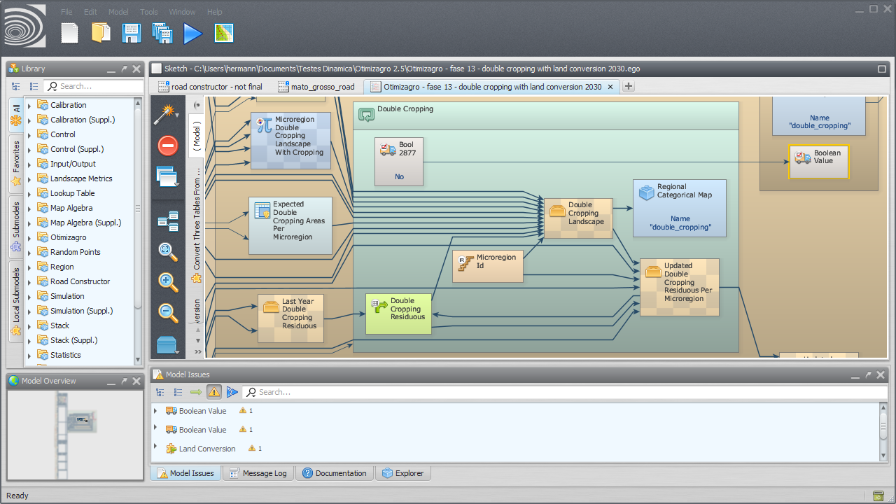Dinamica EGO

Functor Library
Shows functors and submodels. The user can search for specific submodels and iteract with them, viewing the functor documentation, marking functors as favorites etc.

Functor Library Bar
Allows the user to interact with any functor or submodel available at the functor library.
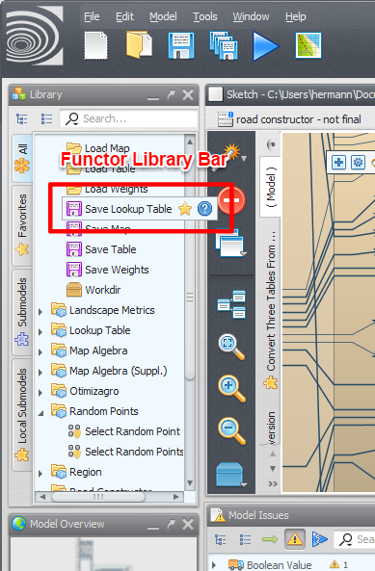Functor Library Bar

Model Presentation
Main painel where all models are presented.
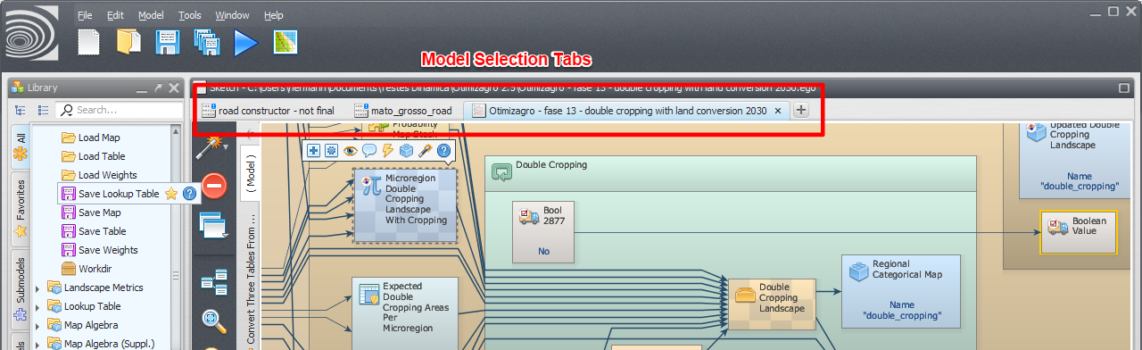Model Presentation

Model Selection Tabs
Tabs use to select the current model.
Model Selection Tabs

Local Submodel Selection Tabs
Tabs use to select the current local submodel or the main model. The main model uses the name “( Model )”. The local submodels have custom names and also uses a custom icon.
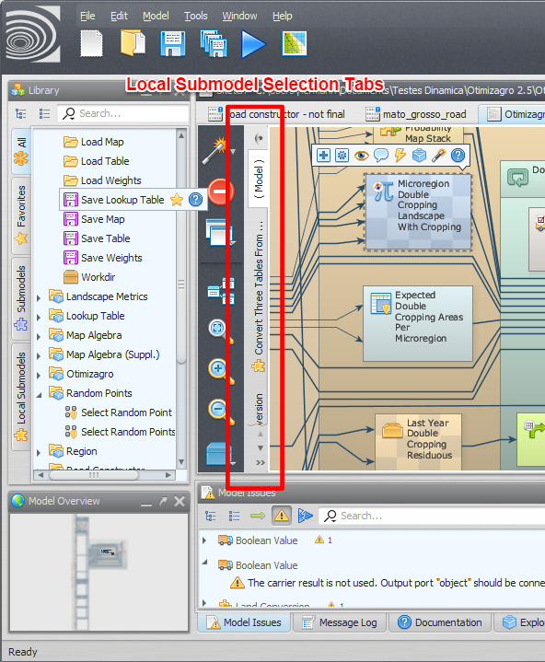Local Submodel Selection Tabs

