Calculate variable time-step net transition rates
Here we provide an example of a model that can be used to run multiple time step simulations when the time-period matrix cannot be decomposed to a multiple-step transition matrix because it is not an ergodic matrix, i.e. Markov chain matrix.
For matrices that cannot be decomposed into multiple-step transition matrices, this models calculates first gross transition rates for a time-period and a specified time-step and then derives variable net transition rates, producing, as a result, a unique transition matrix for each model iteration. Output transition matrices are saved into files that can be loaded in a simulation with the same number of time-steps.
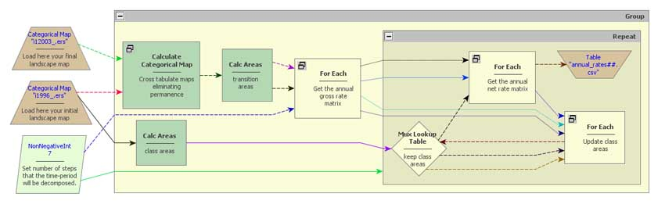
To download this model and another one that runs the simulation using the multiple step transition matrices, please access:
http://csr.ufmg.br/~britaldo/simulate_2003_in_annual_time_steps.zip
To work properly, these models' subfolder must be placed under the folder:
\Examples\run_urban_dynamics_of_savassi_bh (This is an example provided with Dinamica EGO installation)
--- Britaldo Soares Filho 2011/03/11 13:16

