Make Movie
Map Viewer can be used to generated movies (in mp4 format) from a set of maps. This is useful because:
- You can make presentations and display temporal changes in a interactive way.
- Output movies can be read by any devices and/or applications that support mp4, it isn't tied to map formats or Dinamica itself.
- Generated frames for movie can be saved separated in PNG, that way you can also use your favorite movie creation tool.

Movie files
On a computer, movies are just a series of frames (or pictures) that get replaced in a particular time frequency.
Usually, when you see formats like (.mp4) it just means you have a set of images and a sound file tied together. With that in mind,
movies produced by the Map Viewer follow the same definition. The user is required to load the maps (which are going to be the images in the movie)
he wants to display and then configure the viewer main area as if it was the movie itself. Transformations (zoom, pan) are kept on the movie, as well
as histogram curves, palettes for each images and transparency.

Making a movie
- User load the maps he/she wants to display on the movie. Check out Load a map, if you are unsure about how to load maps.
- Transformations are configured, histogram curves are defined and color palette set.
- The movie maker is invoked.

- As soon as the movie maker wizard pops up, the user is prompted to select frames to be replaced (left column) and frames to replace them after each frame (right column).
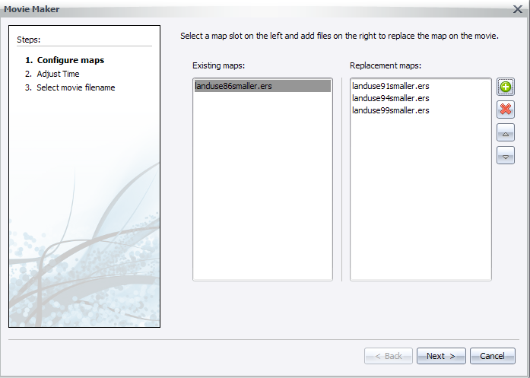
- Next, user configure the time between each frame (a preview of the replace speed will be shown).
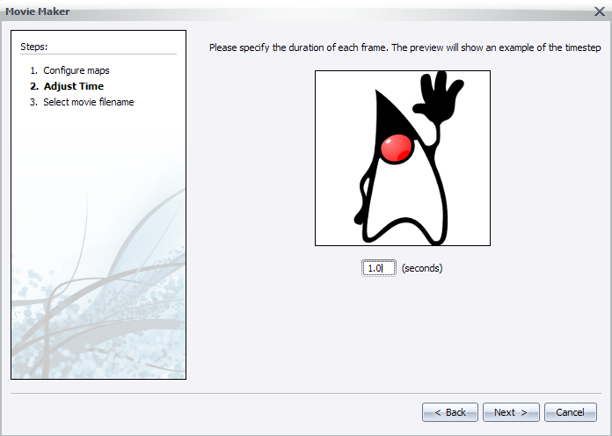
- Finally, user select the final path for the output movie file (the .mp4) and if he/she desires to keep generated frames.
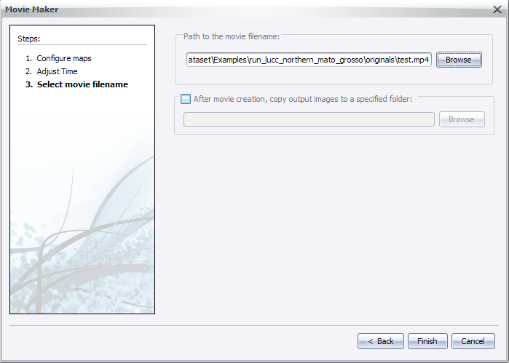
- After clicking next, the user will be prompted to wait while the movie is being generated.
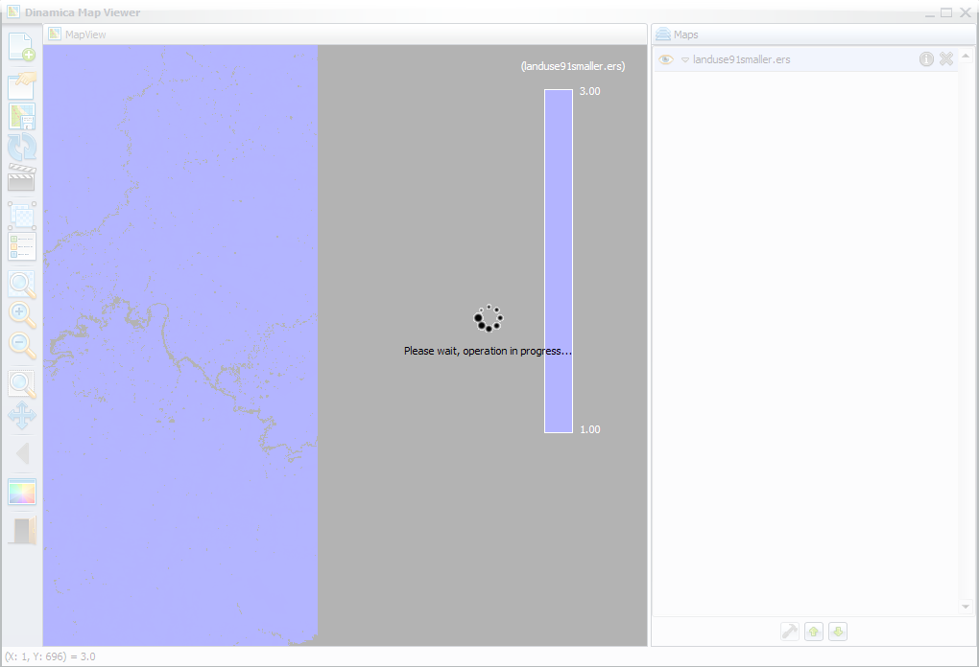
- A good way to keep progress is to watch the changes in frame names, on the Map column in main interface. A notification will pop up when the process finishes.


