MacOS Support Page

R Support
Dinamica EGO 5 on MacOS doesn't ship with an internal R installation, users are responsible for installing a native R package and then configure it with Dinamica EGO 5 R Plugin.
The required R package version is 3.6.1 and you can download it on This link. Follow the on screen prompts for installation.
After the installation is complete, go to Tools -> Options menu:
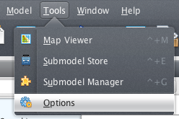
Then set your Rscript path (most of the time the correct path is /Library/Frameworks/R.framework/3.6/Resources/Rscript):
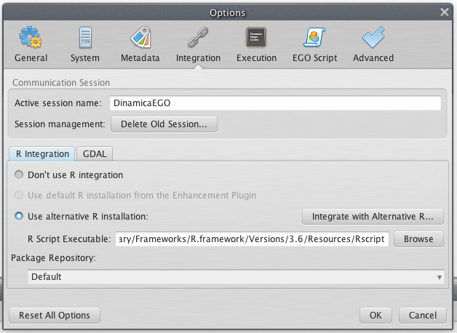
and finally click on the button “Integrate with Alternative R...” to install the Dinamica EGO 5 R plugin.
Once the installation is complete you can use the functor “Calculate R Expression”.

FAQ

Cleanup
In case you want to reset your Dinamica EGO 5 installation to default settings, remove the directory “Dinamica EGO 5” under ~/Library folder and the files ~/.dinamica_ego_5.conf ~/.dinamica_ego_5_system.conf.
You can execute the following command on terminal in order to do this:
rm -rf ~/Library/Dinamica\ EGO\ 5/
rm -rf ~/.dinamica_ego_5.conf ~/.dinamica_ego_5_system.conf

