

MODULE III: Working with tables on Dinamica EGO
Work with tables is critical in data manipulation and most of these operations can be performed on Dinamica EGO.

LESSON 9: Inserting a specific value, creating a new column and retrieving a data column

This lesson is focused on helping you to get and insert a specific value into a table on Dinamica.
Which Functors will you use in this lesson?
• Functors: Get Set Table Value, Add table column set table by key and Get table from key
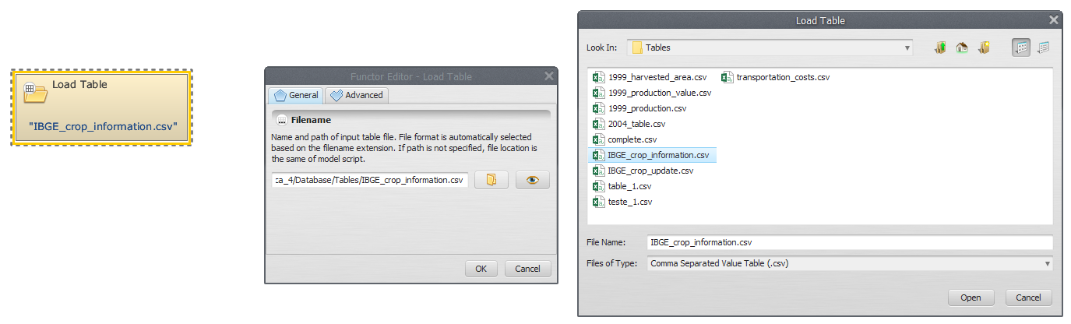
We will use:
-The IBGE crop information Table (Dinamica EGO\Guidebook Dinamica_4\Database\Tables\IBGE_crop_information.csv)
-The 1999_production_value Table (Dinamica EGO\Guidebook Dinamica_4\Database\Tables\1999_production_value.csv)
-The 1999_harvested_area Table (Dinamica EGO\Guidebook Dinamica_4\Database\Tables\1999_harvested_area.csv.csv)
-The 1999_production Table (Dinamica EGO\Guidebook Dinamica_4\Database\Tables\1999_production.csv)
Let's go! Click on the Input/output tab from the library window, grab a Load Table and place it on the sketch. Double click, browse to the folder Dinamica EGO\Guidebook Dinamica_4\Database\Tables and open the IBGE_crop_information.csv file.
Click on the Input/output tab from the library window, grab a Load Table and place it on the sketch. Double click, browse to the folder Dinamica EGO\Guidebook Dinamica_4\Database\Tables and open the IBGE_crop_information.csv file.
 | ATTENTION: Only multi-column CSV - comma separated value format, is accepted
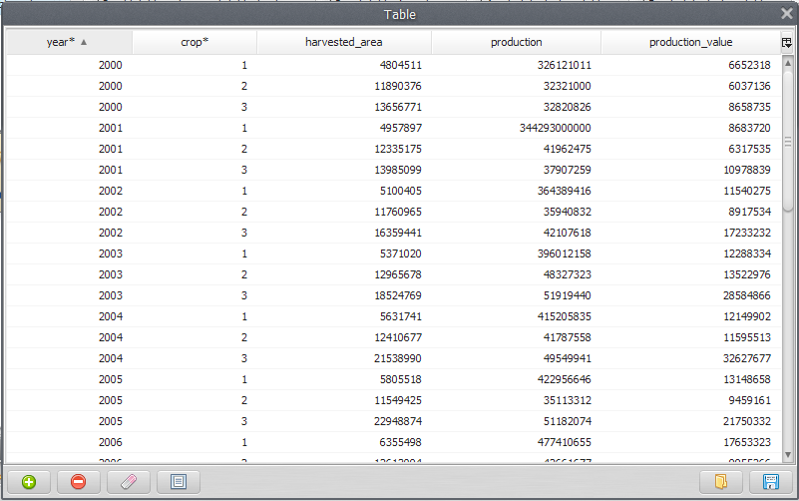
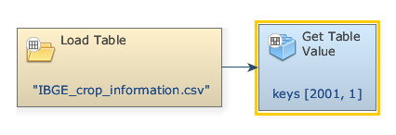
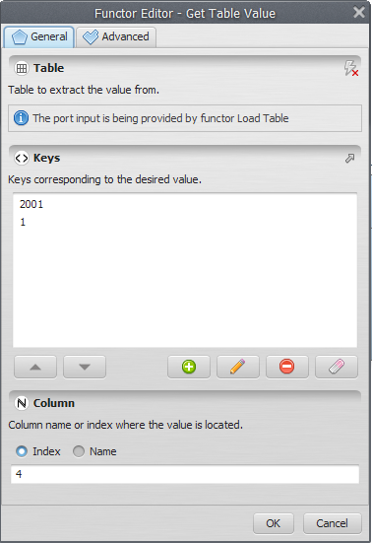
The first two columns are considered the keys of the file, being used to access a certain data in a table. Click on eye button of “Load Table” to see the Table:
In the next step, grab a Get Table Value and place it on the sketch. Connect the functor Load Table in the Get Table value.
Double click the Get Table Value for indicate the Keys corresponding to the certain value and Column name (highlighted by an asterisk). In the box “Keys”, enter “2001”. Next, enter “1” (The Keys to identify the desired value on the table). Also add “4”, i.e., the column name or index where the value is located:
 | TiP: If the given keys are not found in the input table and the “Value If Not Found” parameter is not provided, an error will be reported.
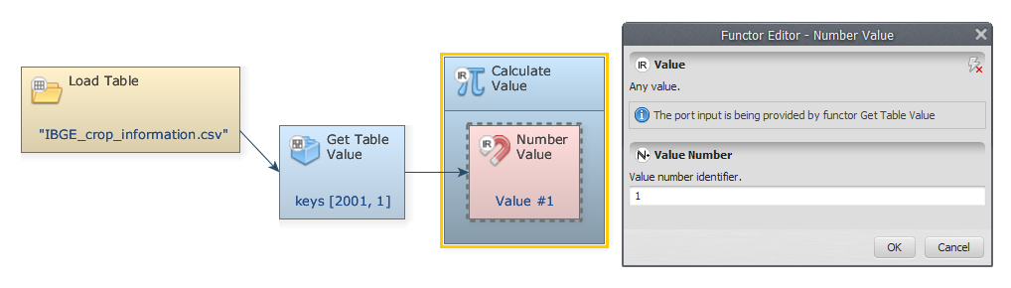
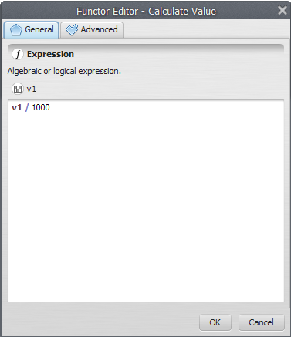
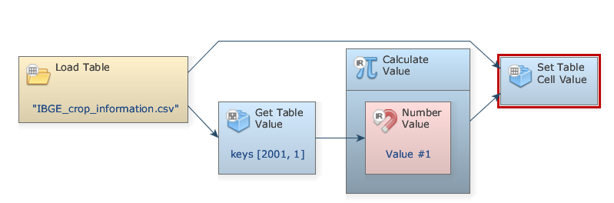
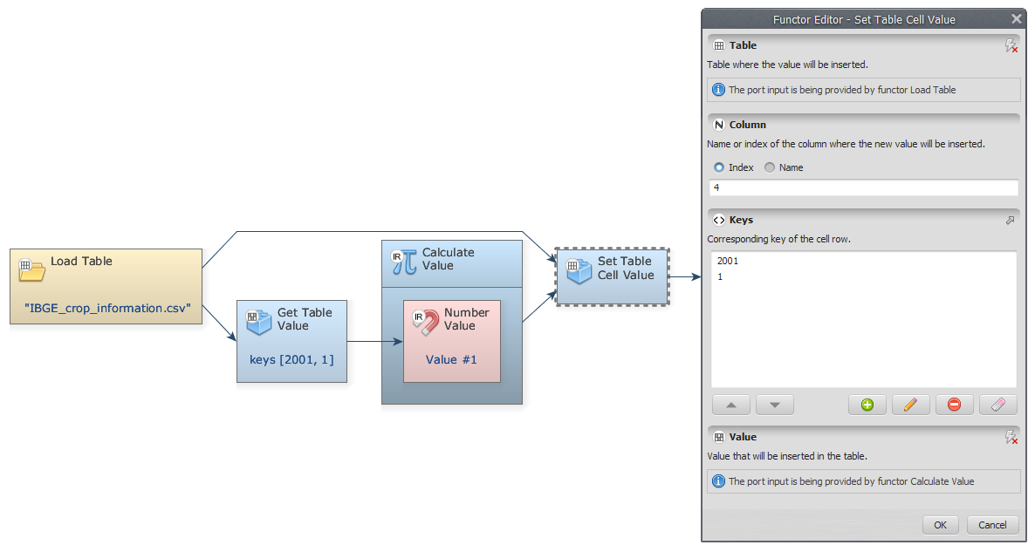
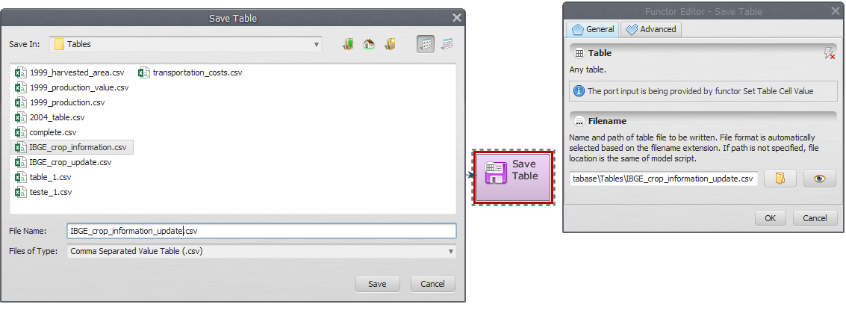
Click on the Table tab from the library window and grab a Calculate Value and place it on the sketch. Assign a number to Number value and connect the functors Get Table Value and Number value. In the “connect port” window, select “Value”.
Double-click on Calculate value to add a logic or an algebraic expression to calculate a value employing it. We divide v1 (the selected value) by 1000 and click OK.
Click on the Table tab from the library window and grab a Set Table Cell Value and place it on the sketch. Connect the container Calculate value and the functor Load Table to the Set Table Cell Value. In the “connect port” window, select “Value”.
Double-click on Set Table Cell value. To identify where the value is located, on the box “Keys”, enter “2001”, “1” (Corresponding to Year 2001 and Crop 1) and add the index “4”.
Click on the Input/output tab from the library window and grab a “Save Table” and place it on the sketch. Connect the functor Set Table Cell Value to Save Table.
Now you need to save the result to a file. Open Save Map, select a folder and write a name file to save (suggestion: IBGE_crop_information_update.csv).
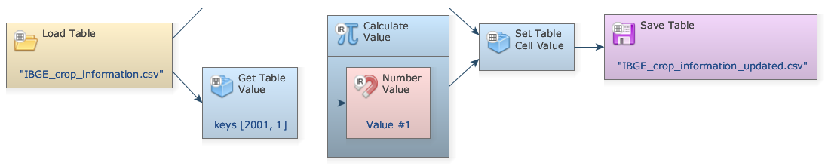
Mark the eye button at the top of “Save Table” to viewer the results hereafter.
The final model will look like this:
Save your model (Disk button on the main tool bar) and then run it by clicking on the run button (blue arrow on the main tool bar).
Now, click on eye button of “Save Table” to see the result. This functor output is table that looks like this:
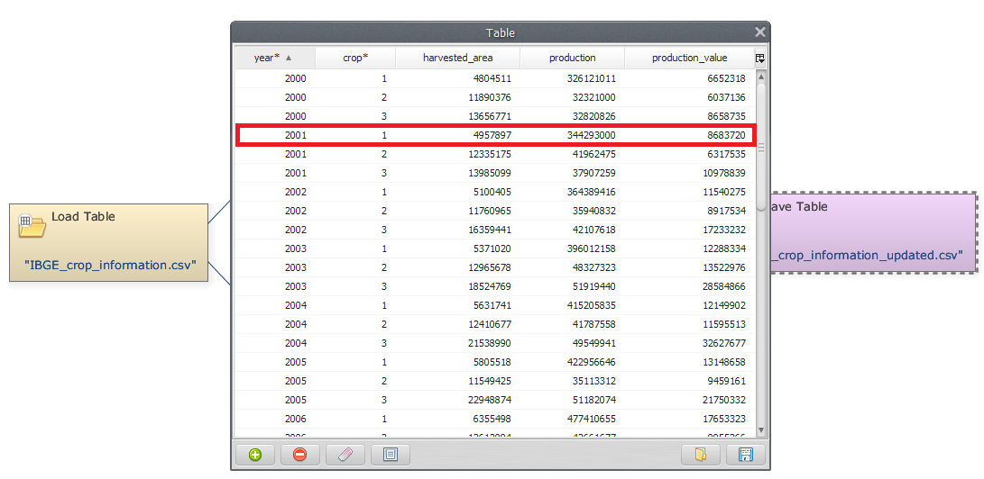
In the first step of this lesson, your model is loading “IBGE_crop_information.csv” file and then getting and inserting a specific value into a table. The new table will be saved with a crop 1 on year 2001 been divided by 1000.
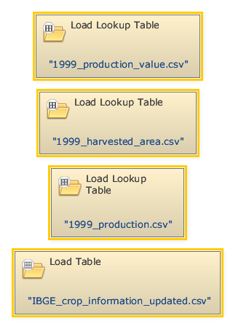
Now, Go ahead to create a new column in the given table
We must open all the files that will be used. Click on the Input/output tab from the library window and grab three “Load Lookup Table” Functors and one “Load Table” and place it on the sketch. Open the Load Lookup Table functors and load the files 1999_production_value.csv, 1999_harvested_area.csv and 1999_production.csv from folder “Tables”. Next, Open the Load Table functor and load the file IBGE_crop_information_uptated.csv.
Now, can create a new column merge with 1999_harvested_area.csv and 1999_production.csv files. Click on the Input/output tab from the library window and grab a Add Table Column and place it on the sketch. Connect the Load Lookup Table which contains the file 1999_harvested_area.csv to Add Table Column. On the Functor Editor window, write a name for the created column (it can be “production_value”).
 | IMPORTANT: The position where the new column is inserted determines whether the new column is a key or data column.
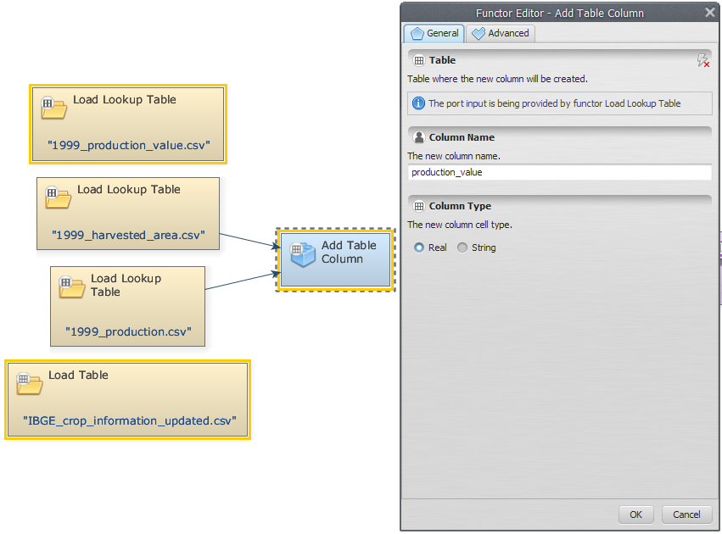
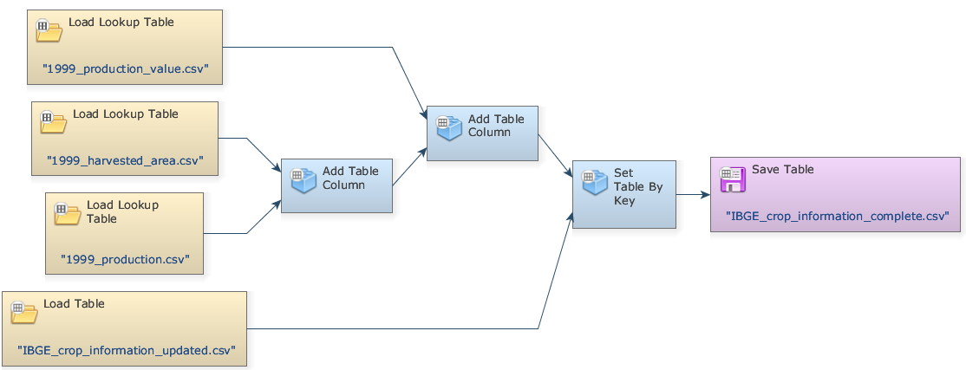
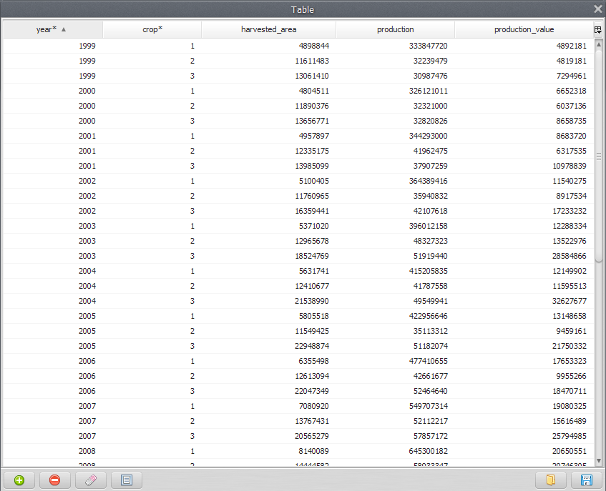
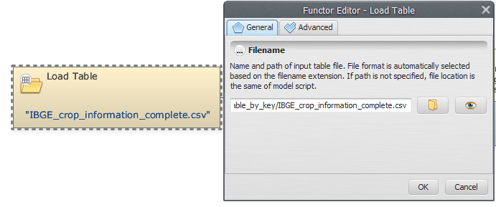
Connect the Load Lookup Table which contains the file 1999_production.csv to Add Table Column. Finally, connect the Load Lookup Table which contains the file IBGE_crop_information_uptated.csv to Set Table by Key. Now you need to save the result to a file. For this, open Save Map functor and browse to the Dinamica EGO\Guidebook Dinamica_4\Models\Set_2\basics\ to determine where the file will be saved and write the name file (Suggestion: “IBGE_crop_information_complete.csv”).
Mark the eye button at the top of “Save Table” to viewer the results hereafter.
Click on the layout tool Left to Right and your final model will look like the one below:
Save and run the model!
Now, click on eye button of “Save Table” to see the result. This functor output is table that looks like this:
Now, using the table generated previously, we would like to demonstrate how to retrieves a data column from the specified table.
First, grab a “Load Table” and place it on the sketch. Double click the Load Table Functor and open the IBGE_crop_information_complete.csv file.
Now, we can retrieve data column table corresponding to harvested area. For this, grab a “Get Table Column functor” and place it on the sketch. Connect the Load Table to Get Table Column. In the tab “Column Index or Name”, insert the index of the column to be retrieved (“3” or “harvested area”).
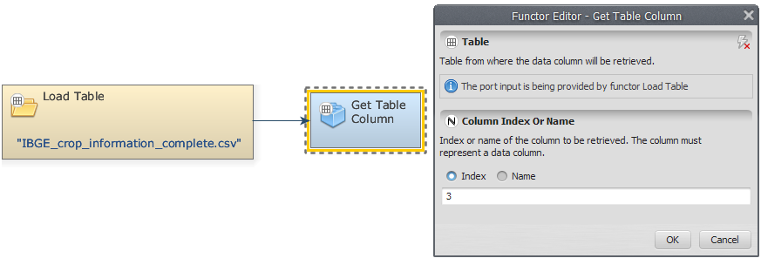
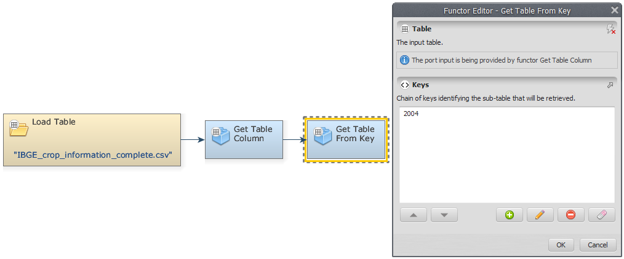
Now, we can retrieve the harvested area per crop corresponding to 2004 year. For this, grab a “Get Table from key” and place it on the sketch. Connect the Get Table Column to Get Table from Key. In the tab “Keys”, insert the year you want to retrieve the harvested area per crop (In this example, “2004”).
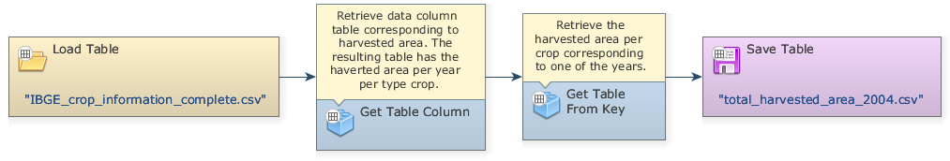
Now, grab a “Save Table” and place it on the sketch. Connect the functor Get Table from Key and Save Table. The final model will look like this:
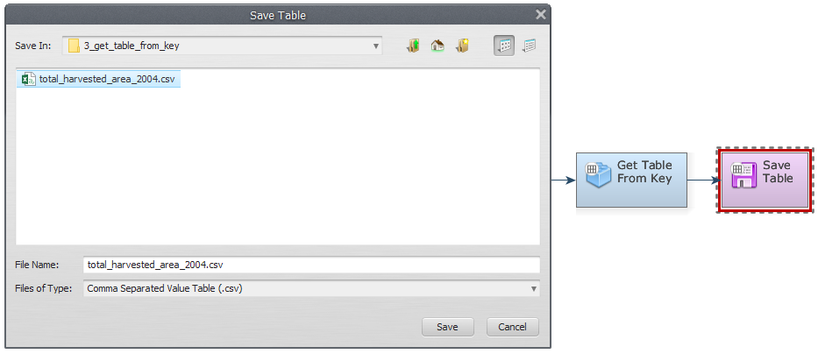
Now you need to save the result to a file. Open Save Map, browse to the Documents\GuideBook Dinamica\Guidebook Dinamica_4\Models\Set_2\basics\ Get_Table_from_Key and write the name file (it can be IBGE_crop_information_update.csv).
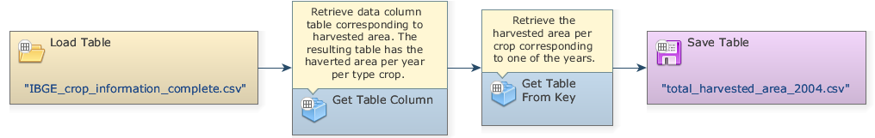
Mark the eye button at the top of “Save Table” to viewer the results hereafter. Click on the layout tool Left to Right and your final model will look like the one below:
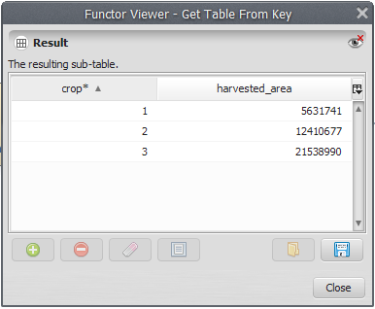
Save and run the model! Now, click on eye button of “Save Table” to see the result. This functor output is table that looks like this:

