Model Overview

Model Overview Panel
Overview of the current model or local submodel.
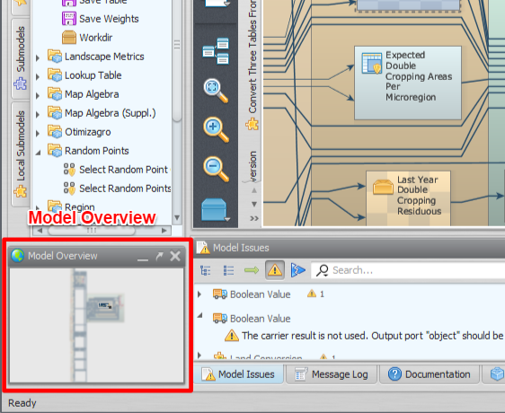Model Overview
It can be used to zoom and pan the current model view.
 | You can also zoom in and out using the mouse wheel directly on the model presentation area. The zoom will be centered around the mouse pointer. You can pan the visualization dragging using the mouse right button.
The following video illustrates the use of the model overview to pan and zoom in and out the presentation of the current model.

